

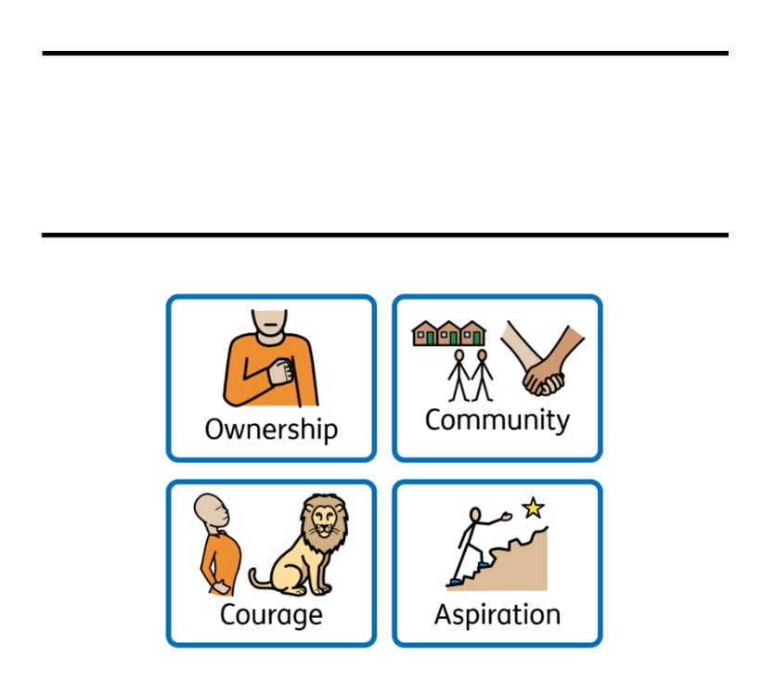
Safeguarding Policy
Child Friendly

Crowcroft Park
Primary School

Crowcroft Park is our school, and we want it to be a safe place for every pupil. We will always do everything we can to make sure that every pupil within our school is safe both inside and outside of school.
Keeping you safe is what matters most to all the staff at Crowcroft Park.
This policy is to help you understand what Safeguarding means to you and to help you decide what could be a “problem” and whom you should talk to.

What is safeguarding?
It is everybody looking after your health, safety and well-being.
Keeping children safe is what matters most to all the grown-ups at school
We want to help you understand what Safeguarding means and who you can talk too if you are worried.

How do we safeguard children at our school?
● All of the grown-ups in our school community understand how to keep you safe. They have been trained to help and support you whenever you need it.
● We follow the rules and guidance we have in place (sometimes called policies) to keep everyone safe. We all take ownership of making our school a safe and happy place.
● We listen carefully to your worries, take them seriously, and make sure they are reported to the right people so that we can help.
● Sometimes we need to talk to other people who can help us understand the best way to support you and keep you safe.
● We encourage you to have the courage to speak to a trusted adult if something is worrying you, and we will always do our best to help.
● We teach you how to keep yourself safe, including learning about bullying, healthy friendships, and staying safe online. We want you to have the confidence and knowledge to make safe choices.
● We care for our school and each other because we are one community. Everyone works together to make our school a welcoming, respectful and safe place to learn.
● We have high aspirations for every child and feeling safe helps you learn, grow, achieve your best and be proud of what you can accomplish.
● We encourage everyone to show our school values of community, ownership, courage and aspiration every day, helping to keep ourselves and others safe.

What should you do if you are worried about something at home or in school?
Sometimes things happen inside or outside of school which might make you feel worried or scared. This could be something an adult does to you, something another child does to you, or even something you see online.
If you are being hurt by someone else, it is never your fault.
If you are worried about anything it is really important to talk to a grown-up in school so we can work together to help you.
You can speak to any of the grown-ups in school or you may choose to speak to one adult in particular.
You can also tell us about your worries using:
The worry boxes in school and the online worry box on our school website if you are not in school

What happens next?
The adults in school will work with you, and sometimes your family to make sure you are safe. Sometimes the adults will need to speak to:
Mrs Nutton-Jones | Mr Moors | Miss Ridgeway | Miss Muldoon or Mrs Hanif
They are designated safeguarding leads. These adults know lots about keeping children safe.
We cannot promise to keep your worries a secret. Sometimes, to help you, we will need to tell somebody else about your worries.
This might include people who help us, like children’s social care (Social Workers) or the police.
We know that talking about your worries can sometimes be scary. Anything that we do will always be done to make sure you stay safe. We will follow our school rules: ‘Respect Ourselves, Respect Others, Respect Property ‘
The adults in our school that are helping you will explain this to you, and you can ask them any questions you need to.

Other ways to get help if you are worried?
There are other people you can contact if you need help outside of our school.
Childline 0800 1111
Police – in an emergency call 999 and ask for the police

