Crowcroft Park Primary School
Uniform Policy

Policy Created Date | Review Date | Agreed By
October 2026 | October 2027 | Full Governing Body

Contents
1. Aims......................................................................................................................................2
2. Our school’s legal duties under the Equality Act 2010 ..................................................3
3. Limiting the cost of school uniform....................................................................................3
4. Expectations for school uniform .......................................................................................4
5. Expectations for our school community...........................................................................6
6. Monitoring arrangements...................................................................................................7
7. Links to other policies..........................................................................................................7

- Aims
This policy aims to:
• Set out our approach to requiring a uniform that is of reasonable cost and offers the best value for money for parents and carers
• Explain how we will avoid discrimination in line with our legal duties under the Equality Act 2010
• Clarify our expectations for school uniform

We have designed:
• Modest clothing that respects cultural context.
• No logo to reduce cost
• Comfortable clothing to enable children to focus on learning.
• Warm layers to support decarbonisation.
• Consistent throughout school to enable second hand uniform provision.
• Local, low cost supplier to support family life.

- Our school’s legal duties under the Equality Act 2010
The Equality Act 2010 prohibits discrimination against an individual based on the protected characteristics, which include sex, race, religion or belief, and gender reassignment.
To avoid discrimination, our school will:
• Avoid listing uniform items based on sex, to give all pupils the opportunity to wear the uniform they feel most comfortable in or that most reflects their self-identified gender.
• Make sure that our uniform costs the same for all pupils.
• Allow all pupils to have long hair (though we reserve the right to ask for this to be tied back).
• Allow all pupils to style their hair in the way that is appropriate for school yet makes them feel most comfortable.
• Allow pupils to request changes to swimwear for religious reasons.
• Allow pupils to wear headscarves and other religious or cultural symbols (though we reserve the right to request that these are plain and unadorned).
• Allow for adaptations to our policy on the grounds of equality by asking pupils or their parents to get in touch with the Deputy Headteacher who can answer questions about the policy and respond to any requests.

- Limiting the cost of school uniform
Our school has a duty to make sure that the uniform we require is affordable, in line with statutory guidance from the Department for Education on the cost of school uniform.
We understand that items with distinctive characteristics (such as branded items, or items that have to have a school logo or a unique fabric/colour/design) cannot be purchased from a wide range of retailers and that requiring many such items limits parents’ ability to ‘shop around’ for a low price.
We will make sure our uniform:
• Is available at a reasonable cost.
• Provides the best value for money for parents/carers.

We will do this by:
• Carefully considering whether any items with distinctive characteristics (logos) are necessary.
• Avoiding specific requirements for items pupils could wear on non-school days, such as coats, bags and shoes.
• Considering alternative methods for signaling differences in groups for interschool competitions, such as bibs or labels.
• Making sure that arrangements are in place for parents to acquire second-hand uniform items.
• Avoiding frequent changes to uniform specifications and minimising the financial impact on parents of any changes.
• Consulting with parents and pupils on any proposed significant changes to the uniform policy and carefully considering any complaints about the policy.

- Expectations for school uniform
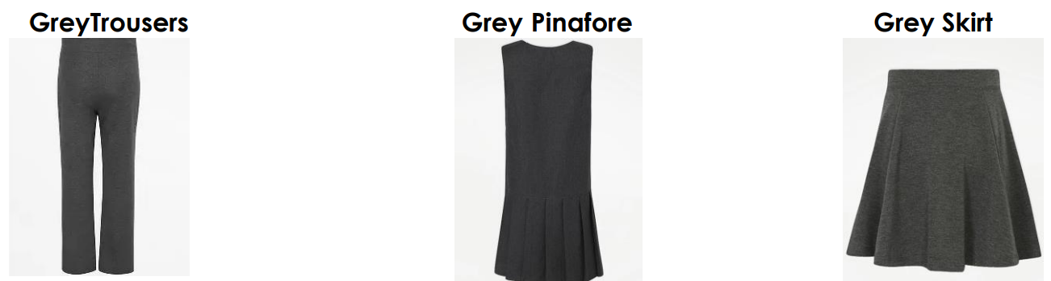
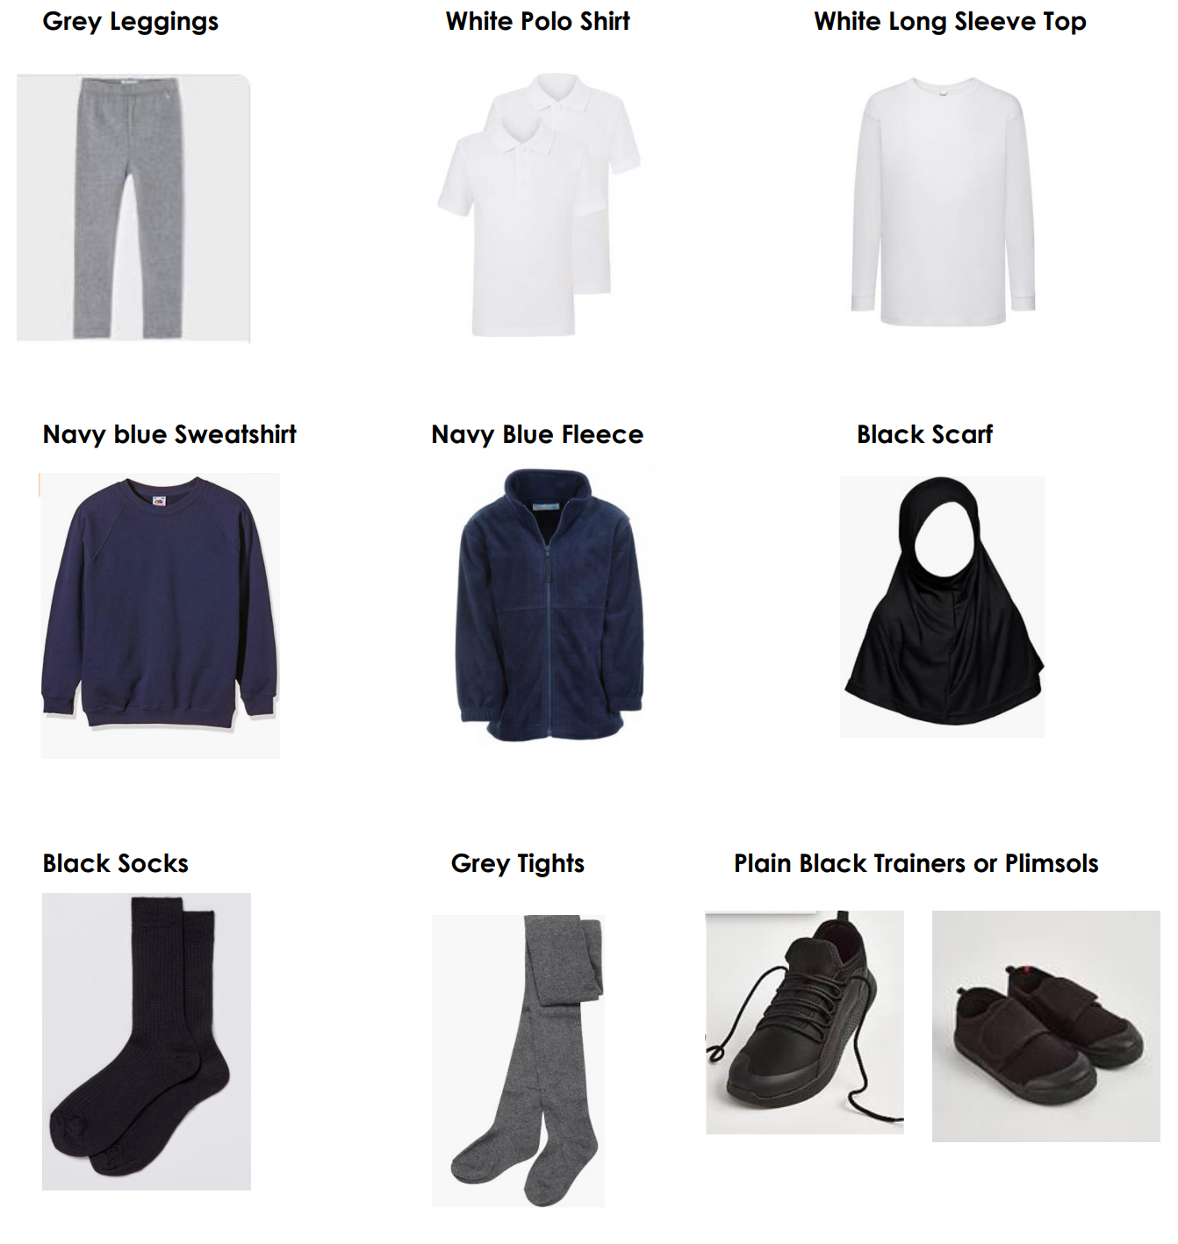
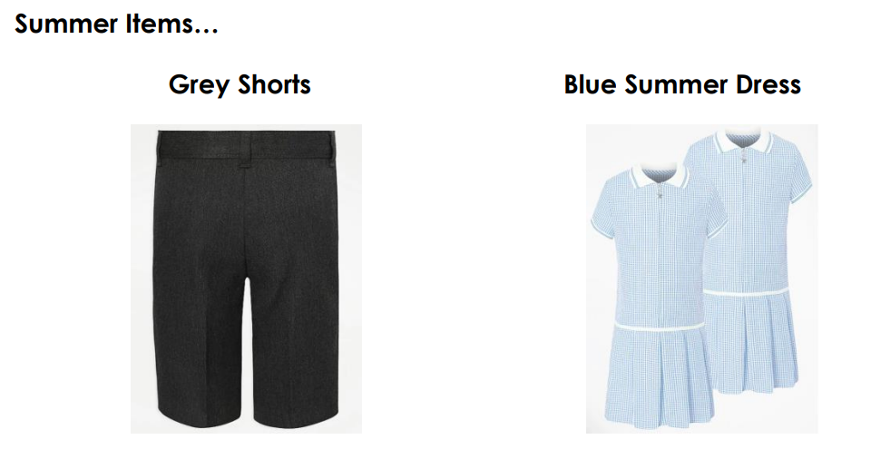
All these items can be bought or from Asda.
Trips & Visits
On trips and visits, it is important that we can recognise children belonging to our school quickly. Children will be provided with a Crowcroft Park bib on school trips. High visibility vests will be worn if the children will be walking on roads as part of a trip (e.g. swimming):
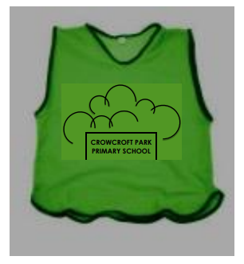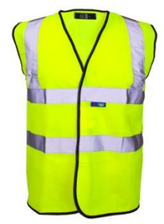
Uniform Exchange
We will set up an annual uniform exchange that is managed by parent volunteers. This will involve:
• Collecting old uniform.
• Checking uniform suitability – only clean, well-maintained (not faded, torn, stained or shrunk) uniform will be exchanged.
• Sorting uniform into size and type and storing.
• Running collection points.
Every child will receive a token entitling them to a single full set of uniform at the termly collection point, dependent on stock availability.
Spare uniform can also be donated and collected from our ‘Give what you can, take what you need’ wardrobe.

- Expectations for our school community
Pupils
Pupils are expected to wear the correct uniform at all times (other than specified non-uniform days) while:
• On the school premises.
• Travelling to and from school.
• At out-of-school events or on trips that are organised by the school, or where they are representing the school (if required).
Pupils are also expected to contact the Deputy Head teacher if they want to request an amendment to the uniform policy in relation to their protected characteristics.
Parents and Carers
Parents and carers are expected to make sure their child has the correct uniform, and that every item is:
• Clean.
• Clearly labelled with the child’s name.
• In good condition.
Parents are also expected to contact the Deputy Head teacher if they want to request an amendment to the uniform policy in relation to:
• Their child’s protected characteristics.
• The cost of the uniform.
Parents are expected to lodge any complaints or objections relating to the school uniform in a timely and reasonable manner. Disputes about the cost of the school uniform will be:
• Resolved locally.
• Dealt with in accordance with our school’s complaints policy.
The school will work closely with parents to arrive at a mutually acceptable outcome.
Staff
Staff will closely monitor pupils to make sure they are in correct uniform. They will give any pupils and families breaching the uniform policy the opportunity to comply, but will follow up with the Head teacher if the situation doesn’t improve. Ongoing breaches of our uniform policy will be dealt with sensitively to understand and address the underlying causes.
In cases where it is suspected that financial hardship has resulted in a pupil not complying with this uniform policy, staff will take a mindful and considerate approach to resolving the situation.
Staff
The SENDCO will work with families whose children need adaptations to the uniform due to SEND.
Governors
The governing body will review this policy and make sure that it:
• Is appropriate for our school’s context.
• Is implemented fairly across the school.
• Takes into account the views of parents and pupils.
• Offers a uniform that is appropriate, practical and safe for all pupils.
The board will also make sure that the school’s uniform supplier arrangements give the highest priority to cost and value for money.

- Monitoring arrangements
This policy will be reviewed every three years by the Deputy Head teacher. At every review, it will be approved by the governing body.

- Links to other policies
This policy is linked to our:
• Behaviour policy
• Equality information and objectives statement
• Complaints policy

